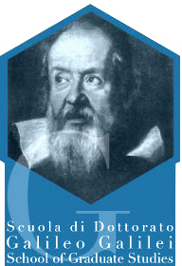 | Università di Pisa  Scuola di Dottorato  Galileo Galilei  School of Graduate Studies

COLLOQUIO GALILEIANO

Prof. Gabriele Veneziano
CdF, CERN

"String Theory: Is Einstein's Dream Being Realized?"

" The long-standing difficulties encountered by Einstein and others in attempts to unify our understanding of the macroscopic (classical) and microscopic (quantum) worlds appear to be elegantly bypassed by string theory. Paradoxically, the solution provided by string theory is based on that same quantum mechanics that Einstein himself was refusing with his famous
"God does not play dice" "

Giovedi 22 Marzo 2007 - ore 17:00
Aula Magna Nuova
Palazzo "La Sapienza"

